1. Which of these is not a function?
a) {(1,1), (2,2), (3,3) b) {(1,2), (2,2), (3,2)}
c) {(1,2), (2,1), (3,4),(4,3)} d) {(1,1), (1,2), (1,3)}

2. If 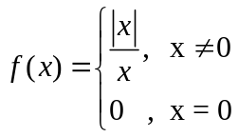 , then which among the following is not true?
a) Left hand limit of f(x) as x→0 = -1 b) Right hand limit of f(x) as x→0 = 1
c) 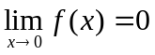 d) Limit does not exist.

3. How should the function 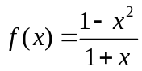 be defined so that it will be continuous at
x = -1?
a) f(-1) = ∞ b) f(-1) = -2
c) f(-1) = 0 d) f(-1) = 2

4. 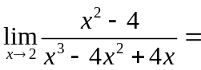
a) 0 b) 4
c) -4 d) Not defined

5. Let A = {9, 10, 11, 12, 13} and let f : A→N be defined by f (n) = the highest prime
factor of n, then the range of f is
a) {3, 5, 6, 11, 13} b) {3, 5, 11, 13}
c) {1, 3, 5, 11, 13} d) {2, 3, 5, 11, 13}

6. Which of the following is not a function?
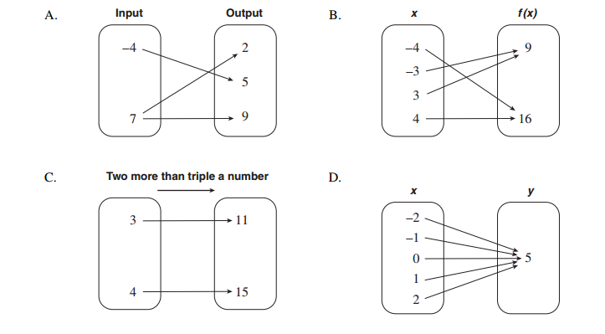

7. 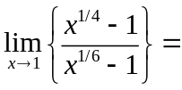
a) 3/2 b) 2/3
c) 1 d) 0

8. 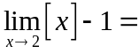
a) 0 b) 1
c) -1 d) Does not exist.

9. Let f: R→R be defined as f(x) = [x] then f is continuous at x =
a) 0 b) -1
c) 1 d) 1/2

10. Let 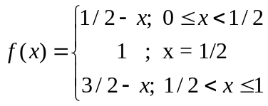 Then, which of the following is false?
a) f is continuous at x = 0 b) f is continuous at x = 1
c) f is continuous at x = ½ d) f is continuous at x = ¼

11. Let f and g be real valued functions continuous at x = c, then which statement is odd?
a) f+g is continuous at x = c b) f-g is continuous at x = c
c) f.g is continuous at x = c d) f/g is continuous at x = c

12. A function whose range consists of just one element is called
a) onto function b) one-one function
c) constant function d) identity function

13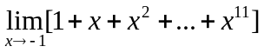=
a) 1 b) -1
c) 0 d) 11

14. Determine the range of the following function.
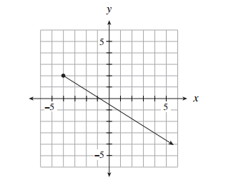
a) (−∞, ∞) b) (−∞, 2]
c) [−4 , ∞) d) (2 , ∞)

15. 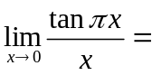
a) 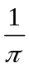 b) 1
c) 0 d)

16. 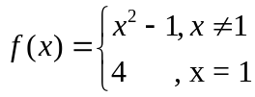

Which of the following statements I, II and III are true?
I. 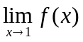 exists II. f(l) exists III. f is continuous at x = 1
a) only I b) only II
c) I and II d) all of them

17. If 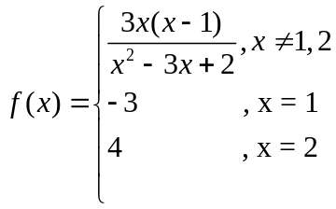 Then f(x) is continuous
a) except at x = 1 b) except at x = 2
c) except at x = 1 or 2 d) except at x = 0, 1 or 2

18. 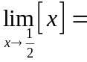
a) ½ b) 1
c) 0 d) Does not exist

19. The function f : R→[-1,1] defined by f(x) = sinx is
a) one-to-one b) onto
c) bijective d) All of the above

20. The value of a for which the following function is continuous at x = 0 is 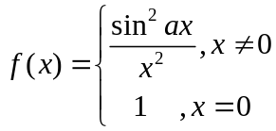
a) 0 b) -1
c) 2 d) f is not continuous for any value of a.

21. If 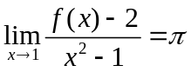 , =
a) Not defined b) 2
c) d) 1

22. Let y = x³ + x⁵, then  at x = 1 is
a) 2 b) 2²
c) 2³ d) 2⁴

23. Derivative of 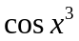 is
a) 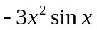 b) 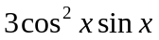
c) 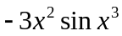 d) 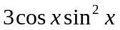

24. If 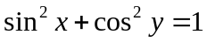 then 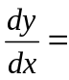
a) 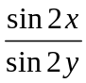 b) 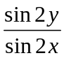
c) 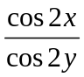 d) 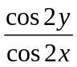

25. If 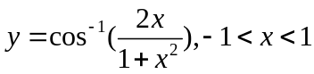 , then
a) 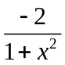 b) 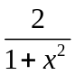
c) 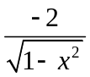 d) 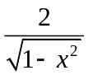

26. If 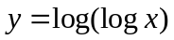, x > 1 then
a) 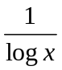 b) 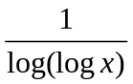
c) 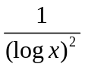 d) 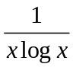

27. If 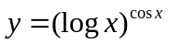 , then
a) 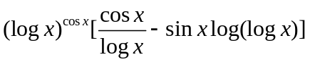 b) 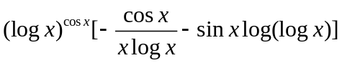
c) 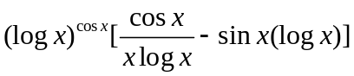 d) 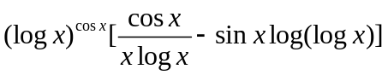

28. If 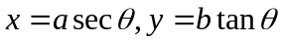, then
a) 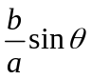 b) 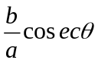
c) 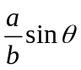 d) 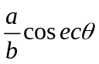

29. If 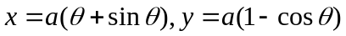 then
a) 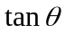 b) 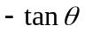
c) 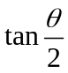 c) 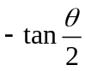

30. The point of discontinuity for the function 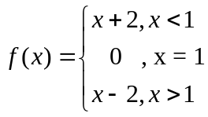 is
a) 2 b) 1
c) 0 d) -1

31. Let 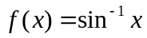 , then domain of f’(x) is
a) R b) (-∞, -1) U (1, ∞)
c) (-1, 1) d) R⁺

